DONEE SALE

LOT OF 8 Boats
$4000
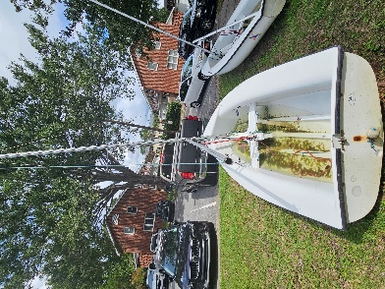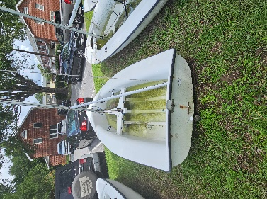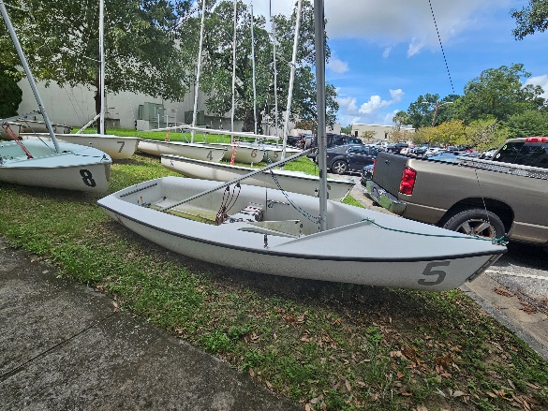

For more information contact
Mark Vuocolo 803-518-9683

